
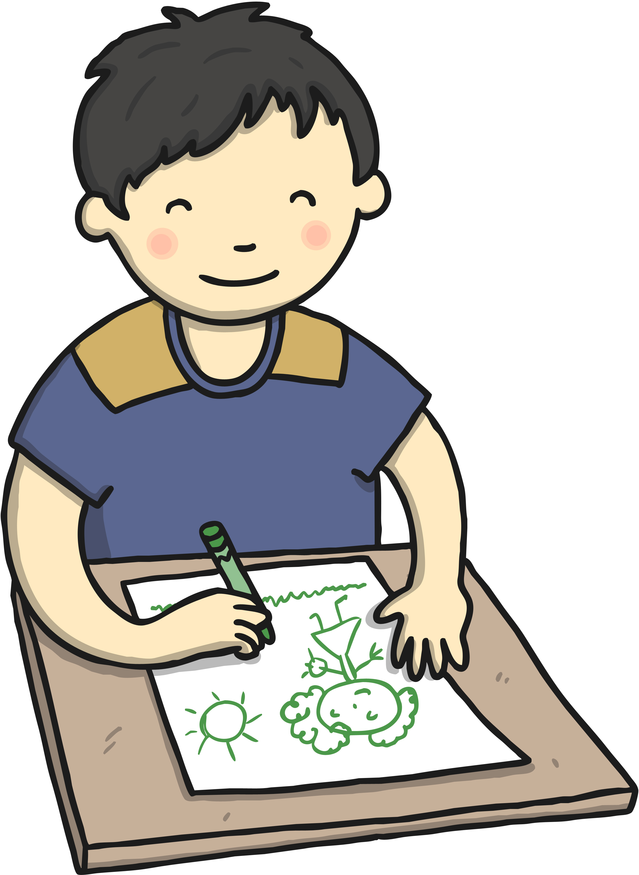
Albury 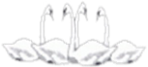

Four Swannes Early Years Newsletter –Autumn 2, 2024
Our learning for the next half term will be based upon the theme of 'Castles’. This topic will help children learn about the different types of houses and how they are built. There will be discussions about houses in the past and present. We will be grateful for donations of any cardboard boxes that will be used for junk modelling.
PE  PE will be held on Friday every week. Reception children will need to come to School wearing their PE kits on Friday.  Book Bags Reception children will need their (named) book bags. These will be for their phonics books and homework only (not for water bottles).  Homework and reading books  Homework and Reading books are sent home every Friday and to be returned the following Wednesday. Please listen to your children read at least 3 times a week. | Important Dates  Monday 11th November 9:00AM – EYFS Maths morning for parents  Friday 15th November – Children in Need day  Tuesday 26th November- Parent’s evening  Wednesday 27th November- Parent’s evening  Friday 6th December – School closed  Monday 9th December – Trip to Chickenshed to watch the show, ‘Christmas tale’  Monday 16th December : EYFS dress rehearsal  Tuesday 17th December : EYFS Nativity performance for parents  Friday 20th December- School finishes at 1:30 for Christmas Holidays
Reminders Children need a named water bottle- containing only water please
Snack from home should be healthy (eg a piece of fruit, or cheese). We do provide a fruit snack for all children.






