
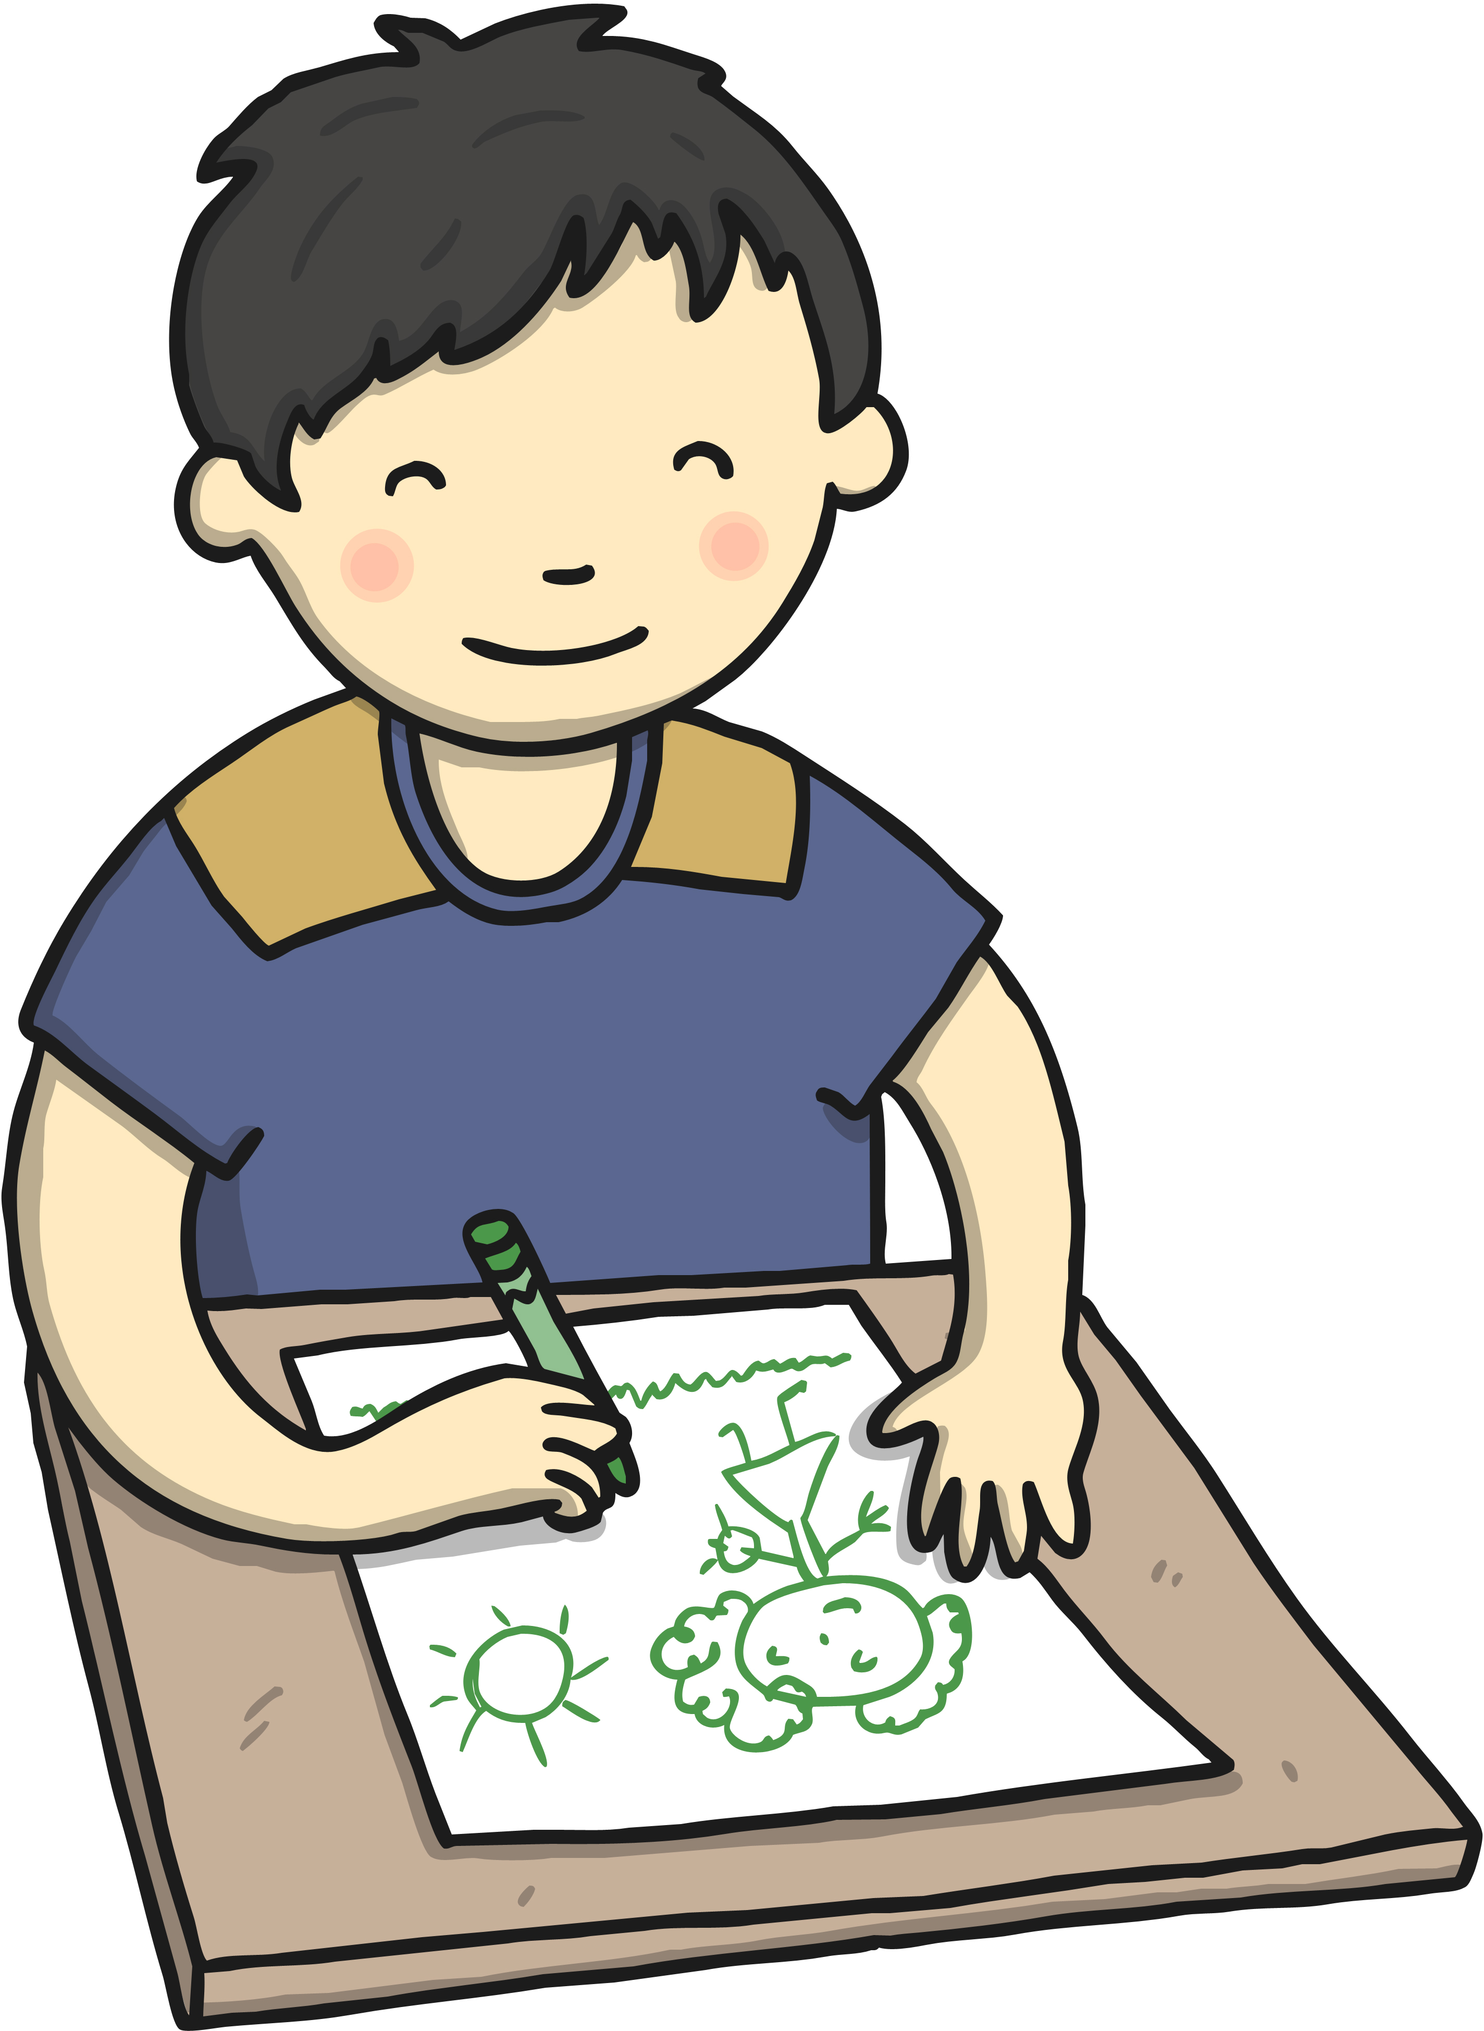
Albury
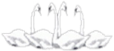

Four Swannes Early Years Newsletter – Spring 2, 2025
Our learning for the next half term will be based upon the theme of 'Farm Animals’. This topic will give children the opportunity to have a scientific focus as they explore the life cycles of farm animals and have a geographical focus as they compare town and cities through books like, ‘Town mouse and country mouse’. We will be reading, sharing our thoughts about and retelling well-known stories such as ‘Farmer Duck’ and ’The three little pigs’.
PE  PE will be held on Friday every week. Reception children will need to come to School wearing their PE kits on Friday.  Book Bags Reception children will need their (named) book bags. These will be for their phonics books and homework only (not for water bottles).  Stay and Play Session  We welcome parents/grandparents/carers to join us for a stay and play session on the last Friday of every month. This is when you can join your child in play or read a book together at drop off time and stay until 9:30 am. | Important Dates  Thursday 27th Feb – CHEXS in AM  Monday 3rd March - EYFS Stay and Play session with a focus on reading (9:00 – 9:30)  Thursday 6th March – World Book Day (Children dress up as characters from books)  Tuesday 11th and Wednesday 12th March- Parents evening  Monday 10th March – Farm animals in School  Friday 14th March – Reception assembly for parents and carers Friday 28th March – EYFS Stay and Play session with a focus on fine motor skills (9:00 – 9:30)  Monday 7th- 21st April - Half Term  Tuesday 22nd April – INSET day (School closed)  Wednesday 23rd April – School opens for the summer term
Reminders Children need a named water bottle- containing only water please. Snack from home should be healthy (eg a piece of fruit, or cheese). We do provide a fruit snack for all children.






