
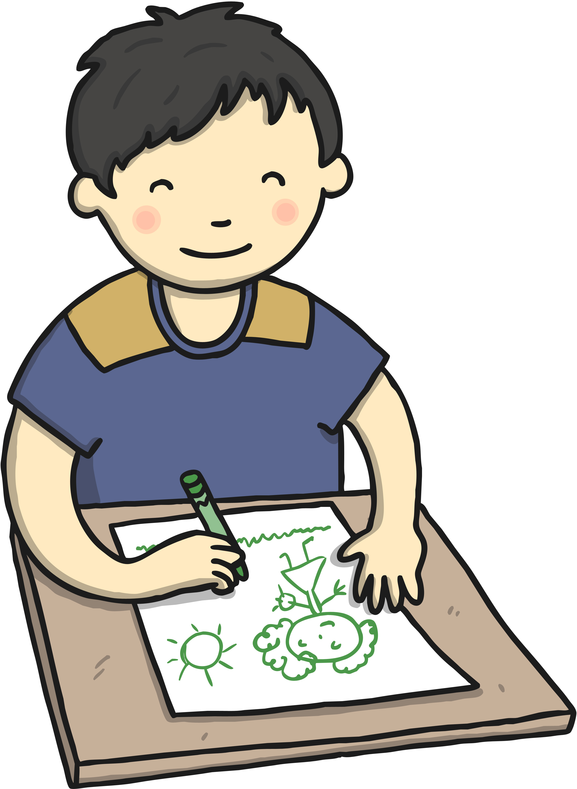
Albury
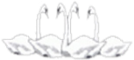

Four Swannes Early Years Newsletter – Summer 1, 2025
Our learning for the next half term will be based upon the theme of 'Minibeasts’. This topic will give children the opportunity to have a scientific focus as they explore the different types of minibeast we find in our garden and how some minibeasts help plants grow. We will be reading, sharing our thoughts about and retelling well-known stories such as ‘The very hungry caterpillar’ and ‘Superworm’, as well as stories from other cultures and countries such as ‘Erol’s Garden’. This will give children the opportunity to compare and reflect on life in other parts of the world.
PE  PE will be held on Friday every week. Reception children will need to leave their PE kit at School. This will be returned at the end of half term for a wash.  Book Bags Reception children will need their (named) book bags. These will be for their phonics books and homework only (not for water bottles).  Stay and Play Session  We welcome parents/grandparents/carers to join us for a stay and play session on the last Friday of every month. This is when you can join your child in play or read a book together at drop off time and stay until 9:30 am. | Important Dates  Friday 25th April - Stay & Play session (9:00 – 9:30)  Monday 12th May – Thursday 15th May- SATs week  Tuesday 20th May - National Child Measurement Programme  Wednesday 21st May – Drama session with Perform for Schools team.  Thursday 22nd May- CHEXS coffee morning (Boundaries and Routines) (10:00 – 11:00)  Monday 26th – Friday 30th May - Half Term  Monday 2nd June – School opens for the summer term
Reminders Children need a named water bottle- containing only water please. Snack from home should be healthy (eg a piece of fruit, or cheese). We do provide a fruit snack for all children.






