L.O. To draw the time correctly and answer duration problems. 1
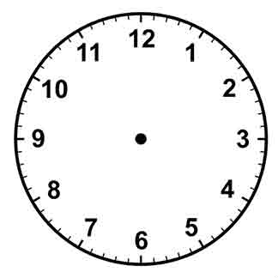 | Jon goes out at 4 O’clock. He comes home 1 hour later.
 | Kim starts reading at 8:30. She stops ½ hour later.
 | Bob gets to the park at 2 o’clock. He stays for ½ hour.
 | Jo watches a 2 hour film. She starts at 2:30.

L.O. To draw the time correctly and answer duration problems. 2
Jon goes out at ¼ past 9. He comes home ½ hour later.
Kim starts reading at 8:30. She stops 45 minutes later.
Bob gets to the park at 2:20. He stays for 45 minutes later.
Jo watches a 50 minute film. She starts at 25 past 7.

L.O. To draw the time correctly and answer duration problems. 3
Jon goes out at 10 to 6. He comes home 25 minutes later.
Kim starts reading at ¼ to 3. She stops 40 minutes later.
Bob gets to the park at 5:55. He stays for ½ hour.
Jo watches a 65 minute film. She starts at 20 to 7.

