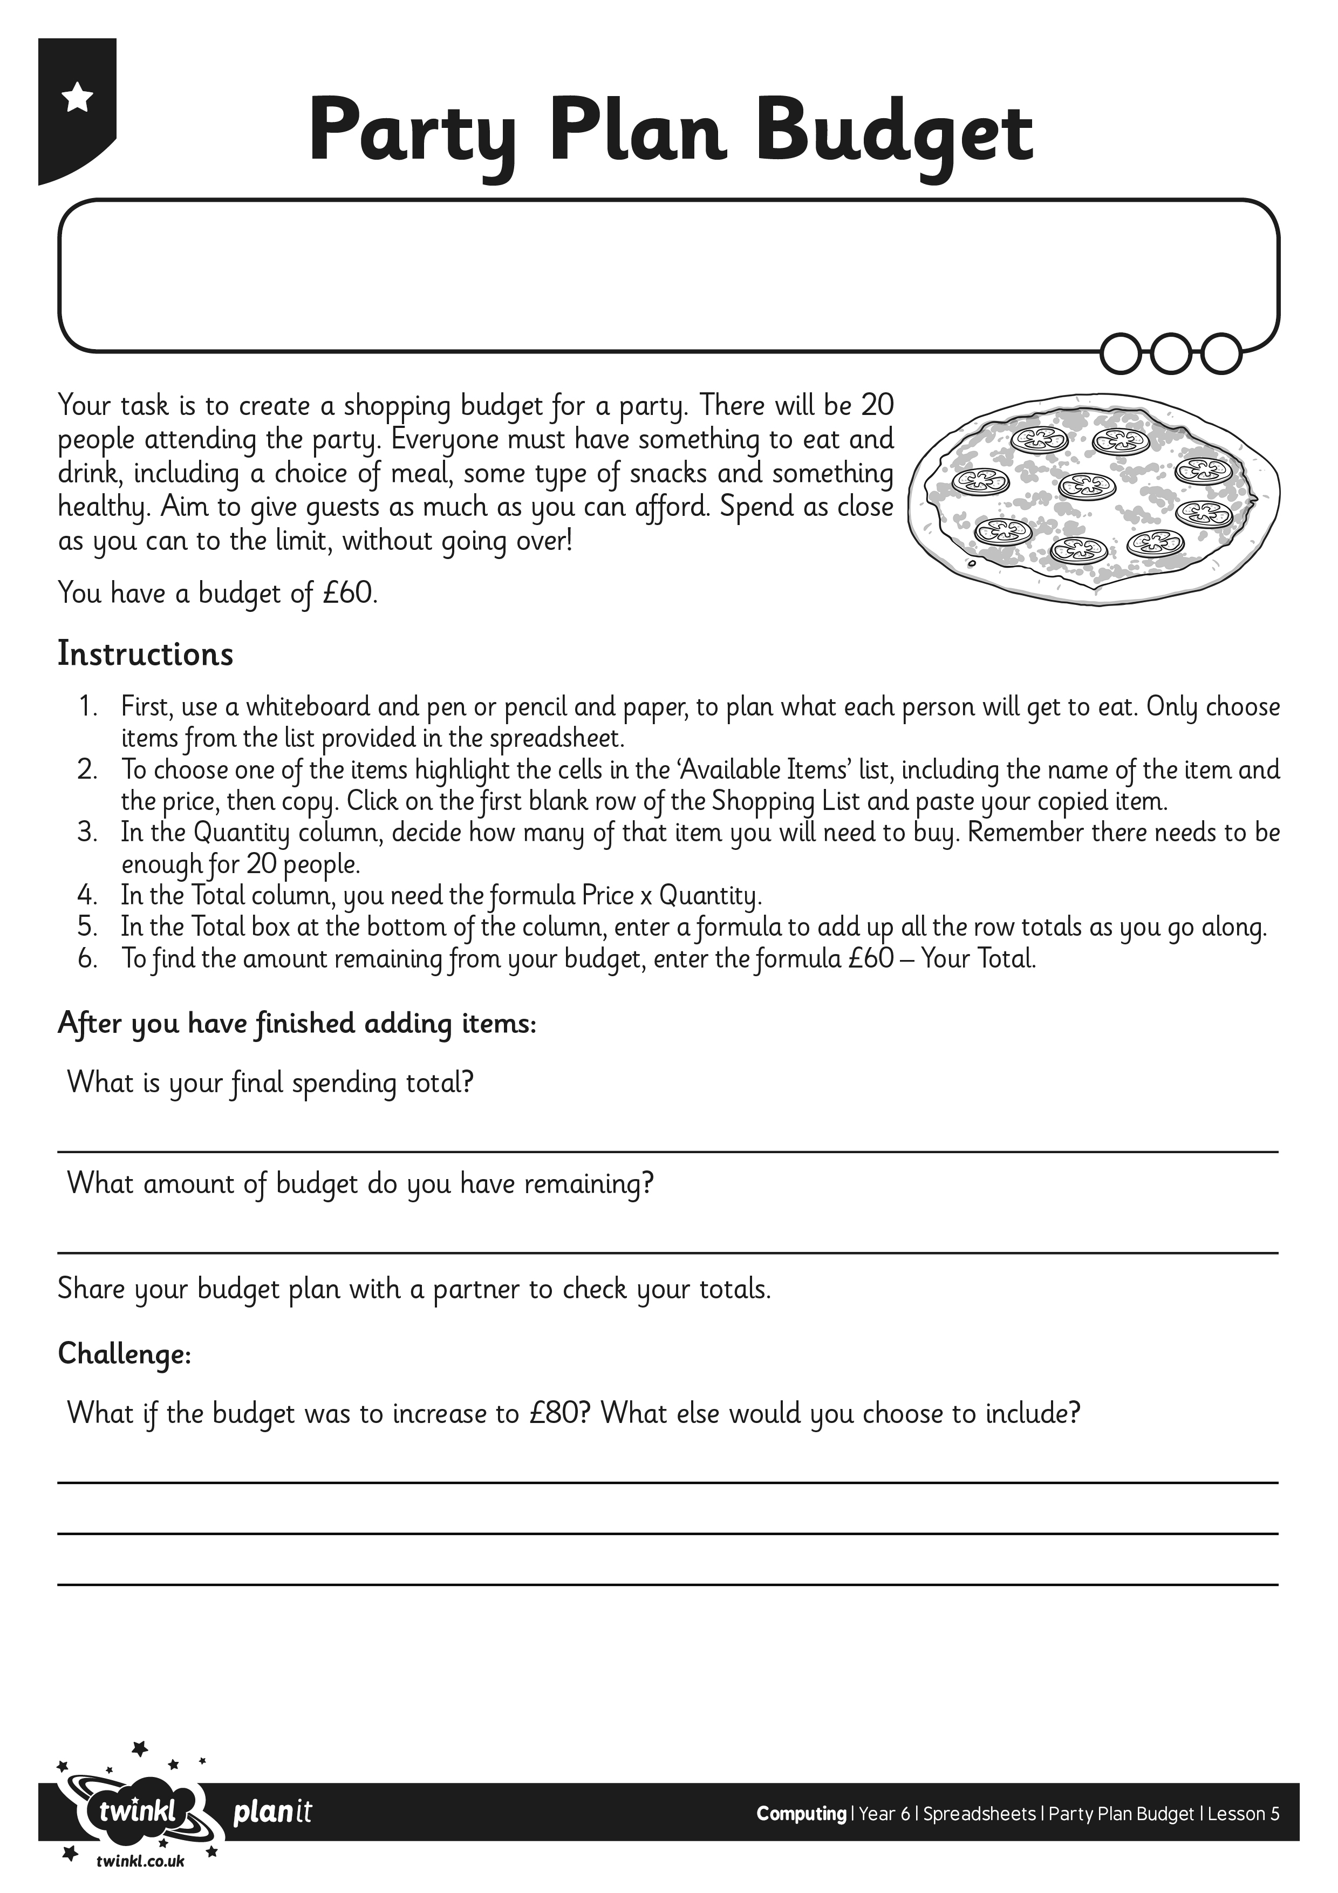
I can plan and calculate a spending budget.
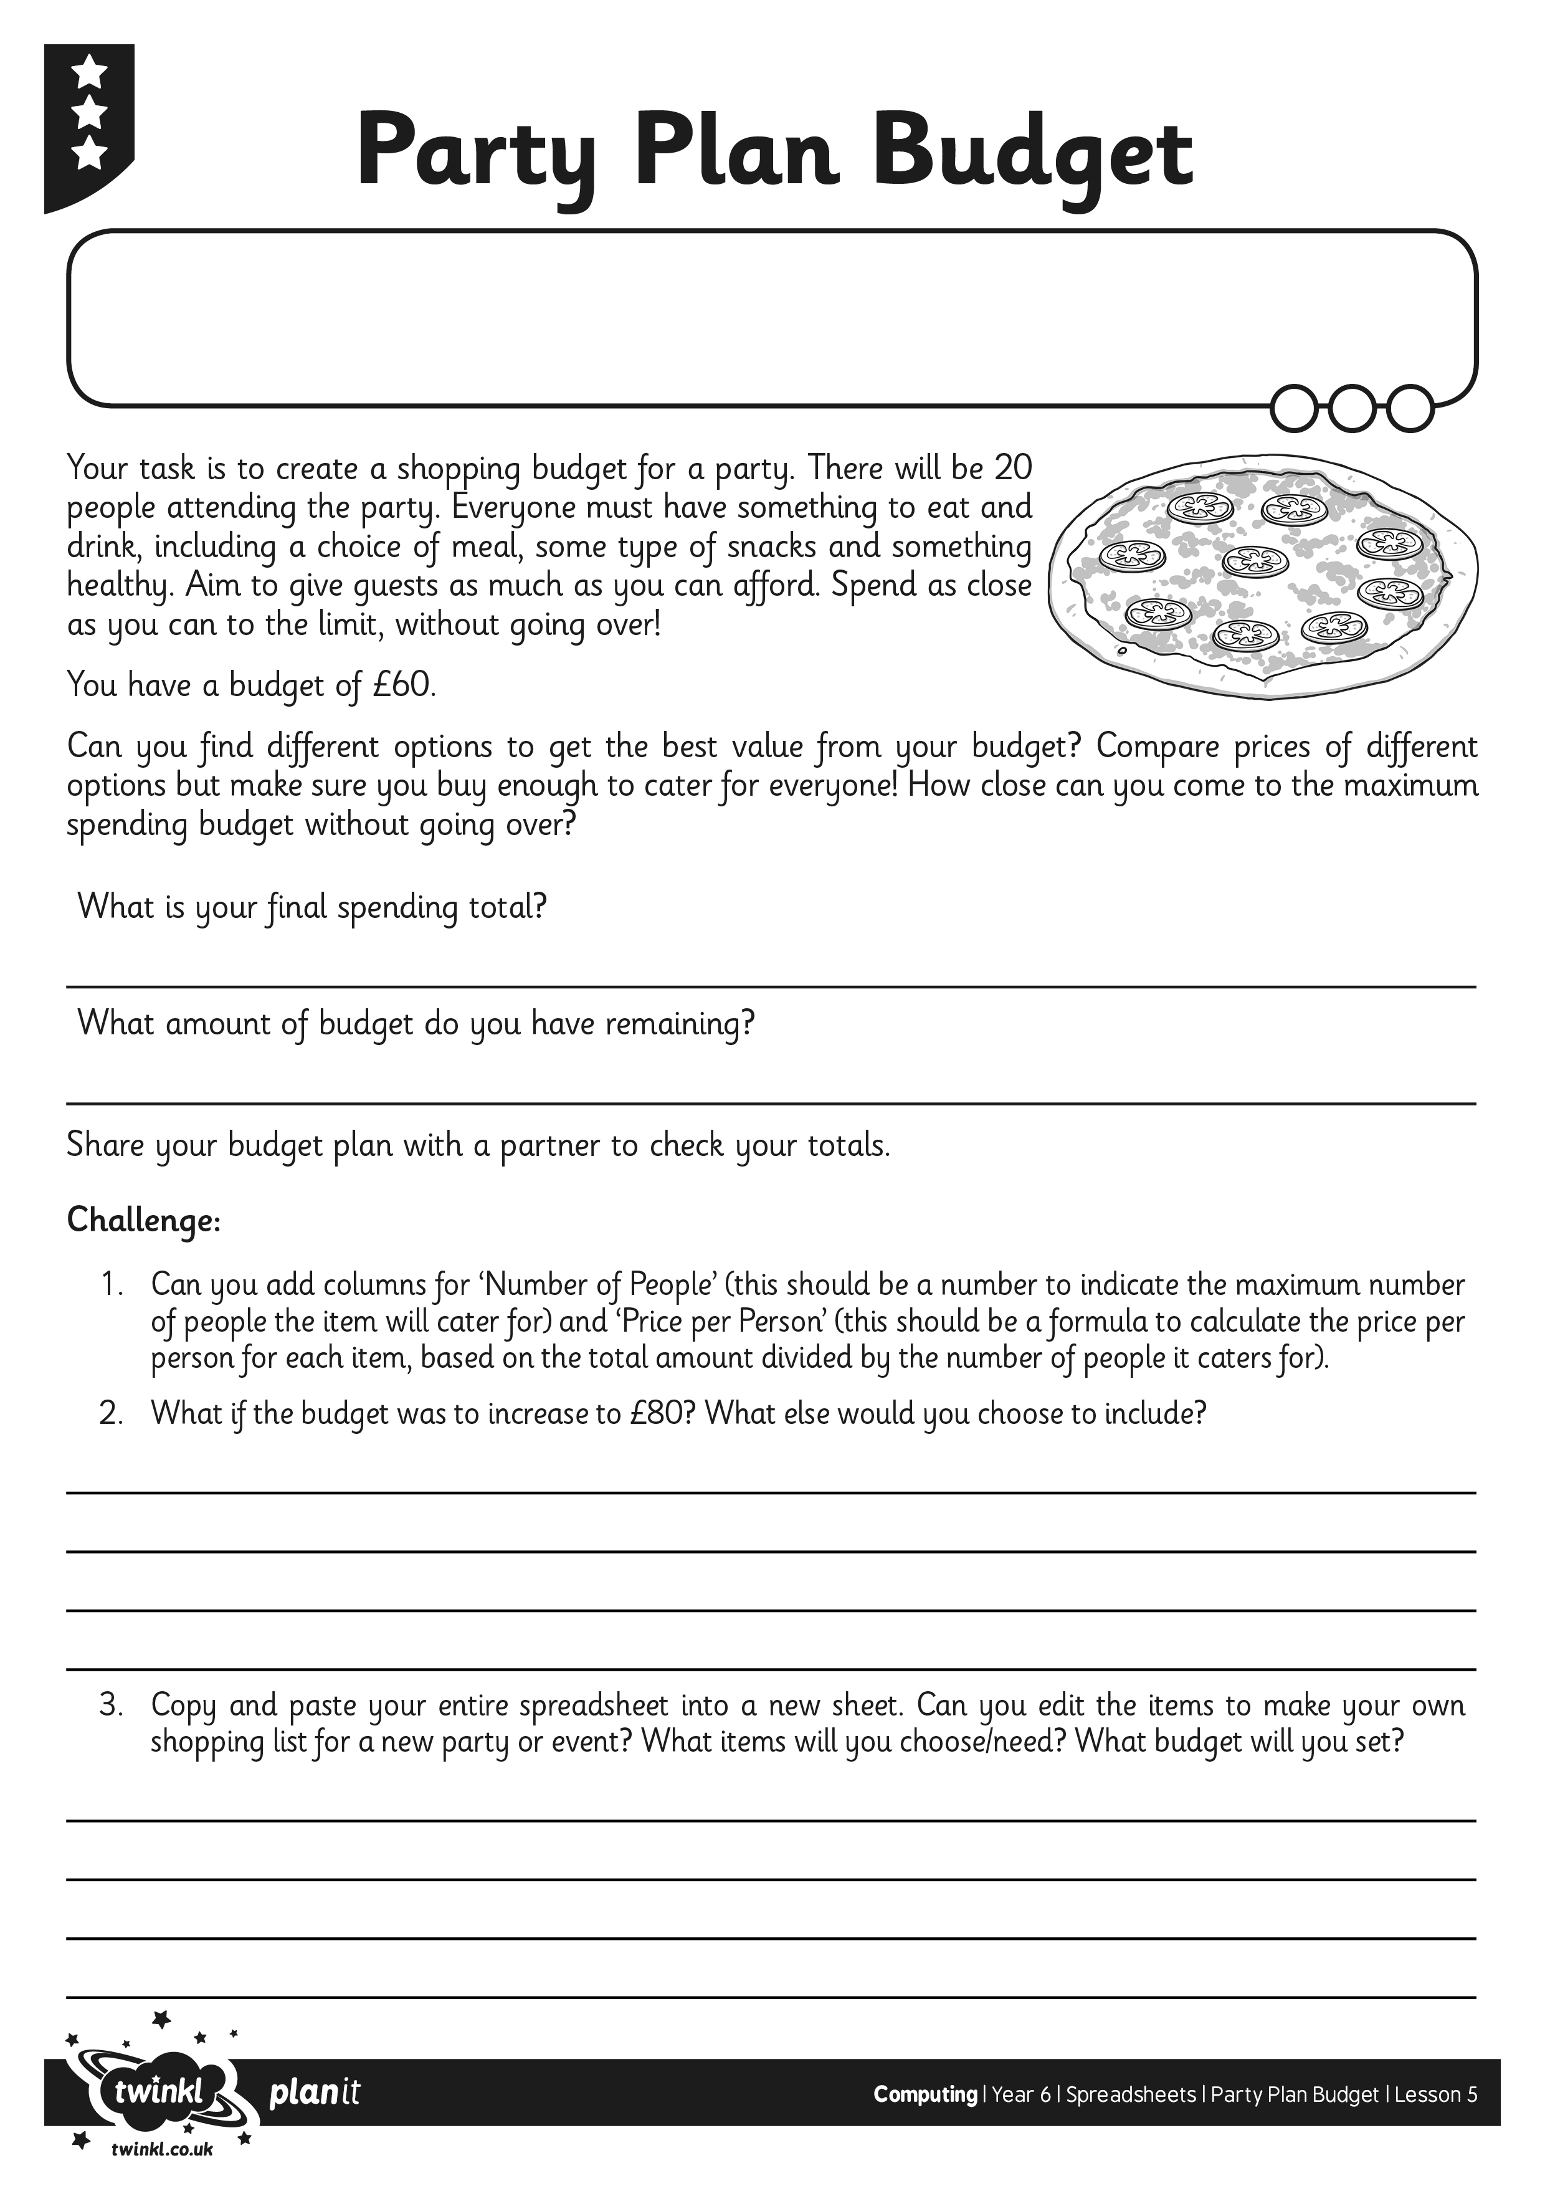
I can plan and calculate a spending budget.

