
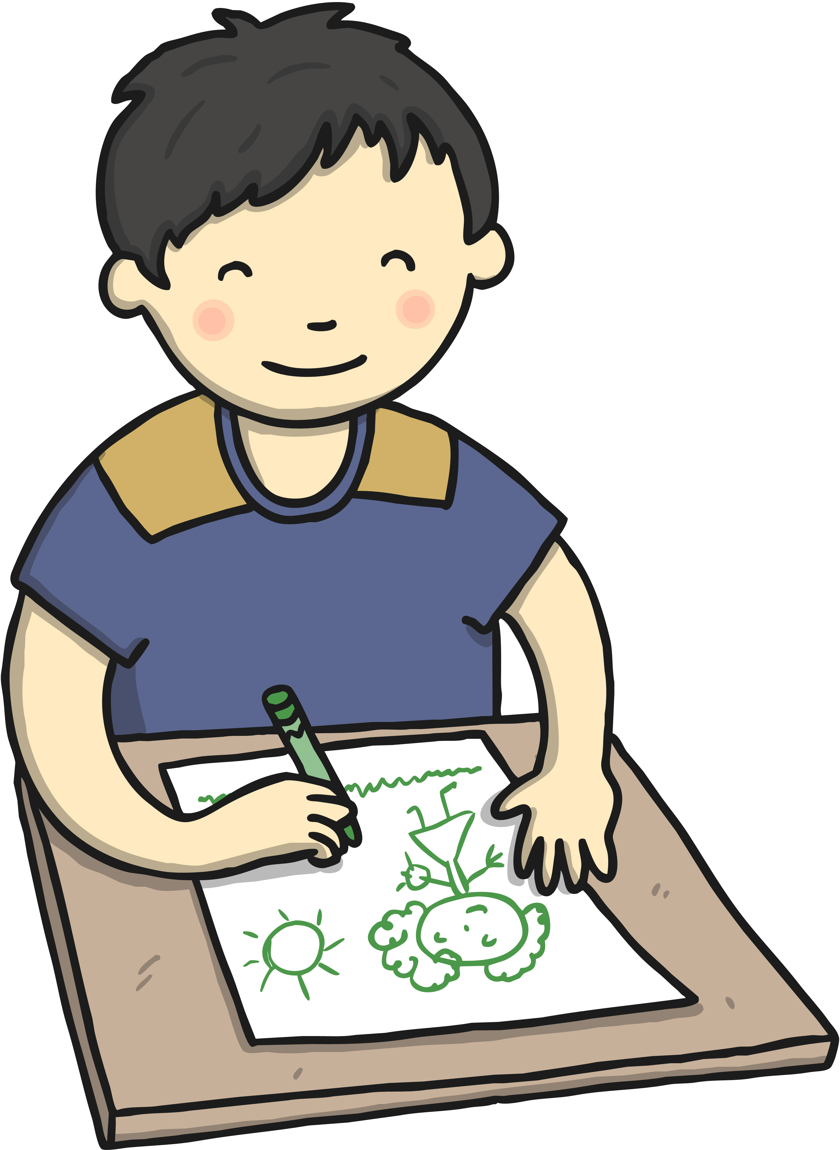
Albury
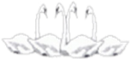

Four Swannes Early Years Newsletter – Summer 2, 2026
This term, our exciting topic is Sea Life! Children will dive into the underwater world to explore the fascinating creatures that live beneath the ocean’s surface. With 71% of the Earth covered in water, our oceans are home to an incredible variety of animals – from tiny shimmering fish and colorful coral to mighty whales and mysterious deep-sea creatures.
Through stories, art, science, and hands-on exploration, children will learn about different sea creatures, their habitats, and the importance of caring for our oceans. This topic will spark curiosity, develop understanding of the natural world, and inspire a sense of wonder about life beneath the waves.
PE  PE will be held on Friday every week. Reception children will need to leave their PE kit at School. This will be returned at the end of half term for a wash.  Book Bags Reception children will need their (named) book bags. These will be for their phonics books and homework only (not for water bottles).  Stay and Play Session  We welcome parents/grandparents/carers to join us for a stay and play session on the last Friday of every month. This is when you can join your child in play or read a book together at drop-off time and stay until 9:30 am. | Important Dates  Thursday 18th June - Sports Day. (Parents invited from 1:00pm) Monday 15th June – Friday 19th June - Scholastic Book Fair Monday 22nd June – EYFS Trip t0 Cedar’s Park  Friday 26th June – Induction meeting for new parents (11am to 12pm) Thursday 9th July – Transition Day Thursday 14th July – Y5 & Y6 production for parents Friday 17th July – Year 6 Leavers Assembly Friday 17th July – School closes at 1:30 for the Summer holidays
Reminders Children need a named water bottle- containing only water please. Snack from home should be healthy (eg a piece of fruit, or cheese). We do provide fruit snacks for all children.






