
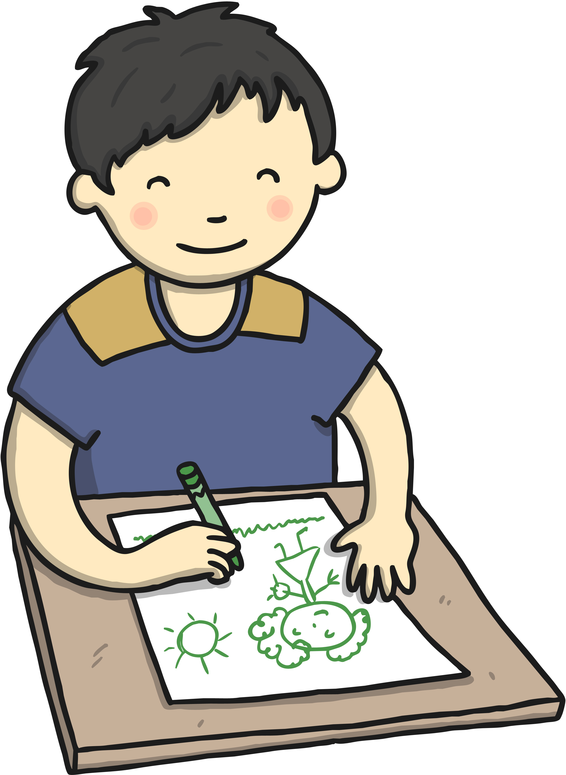
Albury
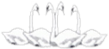

Four Swannes Early Years Newsletter – Spring 2, 2026
Welcome back! This half term our topic is Farm Animals. We are very excited to explore life on the farm and learn all about different animals and how they are cared for. We will be reading farm-themed stories such as: What the Ladybird Heard, Farmer Duck, The Three Little Pigs. If you have any books, photos, or experiences linked to farms that your child would like to share, we would love to see them!
PE  PE will be held on Tuesday every week. Reception children will need to come to School wearing their PE kits on Tuesday.  Book Bags Reception children will need their (named) book bags. These will be for their phonics books and homework only (not for water bottles).  Stay and Play Session  We welcome parents/grandparents/carers to join us for a stay and play session on the last Friday of every month. This is when you can join your child in play or read a book together at drop-off time and stay until 9:30 am. | Important Dates  Friday 27th February –Reception assembly  Tuesday 3rd March – Interactive reading session with author Claire Alexander (Nursery)  Tuesday 3rd March – Create a magical folding illustration with author Claire Alexander (Reception)  Friday 6th March: Dress up for World Book Day  Monday 9th to 13th March: Science week  Wednesday 11th March: Parents evening. Pick up children at 1:15 PM  Sunday 15th March: Mother’s day  Tuesday 17th March: EYFS trip to Lee Valley farm  Friday 27th March: Stay and play session  Monday 30th March to Friday 10th Apil - Easter holiday
Reminders Children need a named water bottle- containing only water please. Snacks from home should be healthy (eg a piece of fruit, or cheese). We do provide fruit snacks for all children.






