

Four Swannes Primary School
SEND Information Report 2026-27
Who are the best people to talk to in this school about my child’s difficulties with learning or Special Educational Needs (SEN)? Pg 2
What are the different types of SEN? Pg 4
How does the school know if children need extra help? Pg 5
What should I do if I think my child may have SEN? Pg 6
How will the school staff support my child? Pg 7
How will I know how my child is doing? Pg 8
How will the learning and development provision be matched to my child’s needs? Pg 9
What support will there be for my child’s overall wellbeing? Pg 10
What training have the staff had, who support children with SEND?
Pg 11
What specialist services and expertise are available at or accessed by our school? Pg 12
How will you help me to support my child’s learning? Pg 13
How will I be involved in discussions about and planning for my child’s
education? Pg 14
How will my child be included in activities outside the classroom including school trips? Pg 15
How accessible is the school environment? Pg 16
Who can I contact for further information? Pg 17
How will the school prepare and support my child to join the school,
transfer to a new school or the next stage of education and life? Pg 18
How are the school’s resources allocated and matched to children’s special educational needs? Pg 19
How is the decision made about how much support my child will receive? Pg 20
How are children and young people listened to? P 21
How can I find information about the Local Authority’s Local Offer of
services and provision for children and young people with special
educational needs and disability? Pg 22
Where else can I find reliable advice concerning SEND? Pg 23
Glossary of terms Pg 24
Who are the best people to talk to in this school about my child’s difficulties with learning or Special Educational Needs (SEN)?
The Head teacher: Mr A Moore, is responsible for:
• The day-to-day assistance in all aspects of school life, this includes the support and
provision for children with SEND.
• The Head teacher will give responsibility to the SENCO and class teachers, but they are responsible for ensuring that your child’s needs are met.
• Making sure the Governing Body is kept up to date about any issues in the school relating to SEND.
• Ensuring our school follows statutory guidance for all pupils including children with special educational needs and or with a disability.

The SENDCO: Mrs Anna Sawyer is responsible for:
• Coordinating support for children with special educational needs and /or with a disability (SEND) and developing the school’s SEN Policy to make sure all children have
access to high quality teaching and provision.
• Supporting teaching staff in the identification of special educational needs, providing guidance and practical advice to remove barriers to learning and deploying support staff
appropriately.
• Reviewing your child’s progress and planning ahead for your child
• Liaising with other agencies who may be coming into school to help support your child’s learning, for example: Speech and Language Therapy, Educational Psychology, School Nurse, Outreach Workers, Advisory Teachers etc.
• Monitoring provision and the impact of interventions.
• Providing specialist support and training for teachers and support staff in the school so they can help pupils with SEN to achieve the best possible outcomes in school.
• Applying for or reviewing Education Health Care Plans for children with more severe or complex needs.
• Ensuring that you are involved in supporting your child’s learning.

The SEN Governor (Mrs J Bailey) is responsible for:
• Making sure that the school has an up to date SEND policy.
• Making sure that the school has appropriate provision and has made necessary adaptations to meet the needs of all children in the school.
• Making sure that the appropriate and necessary support is made for any child who attends the school who has SEN and/or disabilities.
• Making visits to understand and monitor the support given to children with SEND in the school and being part of the process to ensure your child achieves his/her potential in school.

The Class Teacher is responsible for:
- Ensuring that all children have access to good teaching and that the curriculum is adapted to the individual needs of all learners (also known as differentiation.)
- Monitoring the progress of all children in their class and identifying, planning and delivering any additional help that may be needed (this could be things like targeted work, additional support, adapting resources) and discussing amendments with the SENDCO as necessary.
- Keeping parents informed about the support your child is getting.
- Planning for and reviewing provision with support from SENDCO, phase leaders and the leadership team contributing to the assessment process which informs Pupil Progress Meetings.
- Ensuring that all members of staff working within school are aware of children’s individual needs and /or conditions within their class, and what specific adjustments need to be made to enable all pupils to be included and make progress.
- Ensuring that the school’s SEN Policy is followed in their classroom and for all the pupils they teach with SEND.
The Teaching Assistant is responsible for:
- Supporting children in the class, following the guidance of the class teacher
- Carrying out targeted interventions for specific individuals/ small groups
- Keeping assessment records and feeding back observations to class teachers to keep them informed of progress.

What are the different types of SEN?
The SEN Code of Practice 2015, explains that a child is identified as having a Special Educational Need (SEN) if they have a learning difficulty or disability which calls for special educational provision to be made for him or her A child of compulsory school age or a young person has a learning difficulty or disability if he or she: has a significantly greater difficulty in learning than the majority of others of the same age, Or has a disability which prevents or hinders him or her from making use of facilities of a kind generally provided for others of the same age in mainstream schools.

At Four Swannes Primary School we support children with a range of mild and moderate special educational needs.

These include those identified within the SEN Code of Practice (2015)

• Communication and Interaction
This includes pupils with Speech, Language and Communication needs (SCLN) and children with autism spectrum disorder (ASD)

• Cognition and Learning
This includes pupils with general learning difficulties and Specific Learning Difficulties (SpLD) – differences or difficulties with one or more areas of learning.

• Social, Emotional and Mental Health needs
These are educational needs whereby pupil’s have severe difficulties in managing their emotions and/ or behaviour as well as diagnosed conditions such as attention deficit hyperactivity disorder (ADHD) Medical needs

• Sensory and/ or Physical needs
This includes pupils who have a disability which prevents or hinders their ability to use educational facilities or pupils with a visual or hearing impairment.

Pupils will be identified in school through:
✓ Ongoing monitoring of pupil progress through teacher assessment and observation
✓ Discussions between parents, class teachers and the SENDCO.
✓ Discussions from pupil progress meetings.
✓ Internal referrals form for teaching staff to raise concerns that a child needs additional support. This is followed by meetings with the SENDCO and parents/carers.
✓ Further assessments may be necessary when progress and attainment are significantly below age related expectations.

How does the school know if children need extra help?


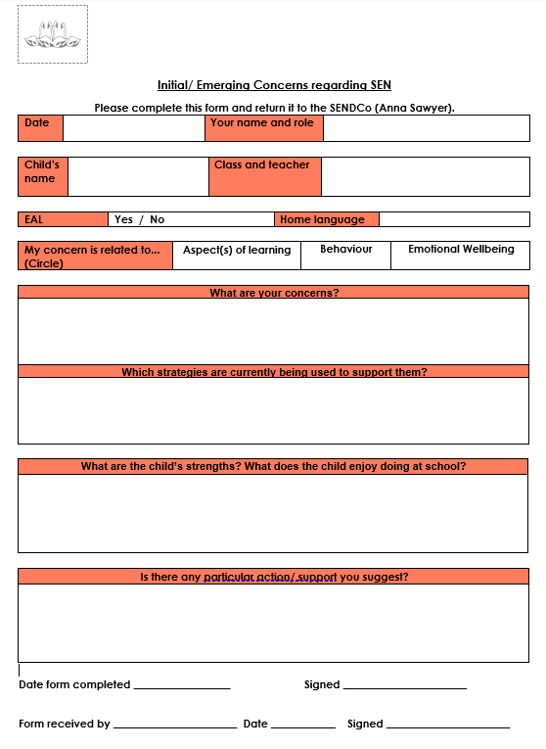

Four Swannes Primary school fully complies with expectations laid out within the SEND Code of Practice. If you would like to find out more about the code, please follow the link below:

Special Educational Needs and Disability Code of Practice: 0 to 25 years

What should I do if I think my child may have SEN?
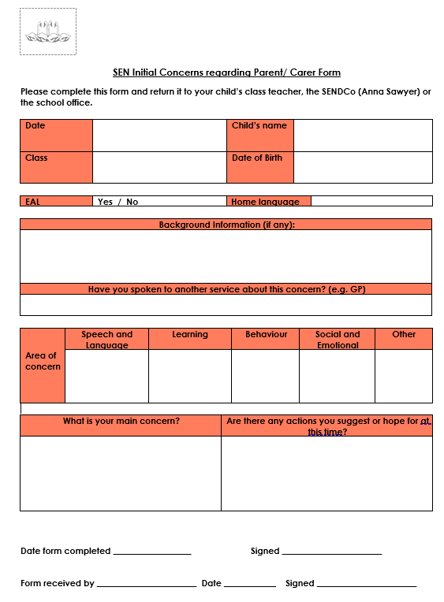
✓ Share your concerns with the class teacher.
✓ Complete an emerging concerns form (see link on website)
✓ Make an appointment to speak with the SENDCO (Anna Sawyer)
Contact on: sendco@fourswannes.herts.sch.uk
✓ Be actively involved in sharing information about what is working well and what might need to change.
✓ Attend all parent teacher consultations

Maintaining regular contact with school is very important at this stage. You will be asked to share your ideas on how best to support the needs of your child, and your child will be invited to share their ideas too.

You can do this by emailing sendco@fourswannes.herts.sch.uk or by telephone on 01992 763939.



How could the school staff support my child?
✓ Through Ordinarily Available Provision, as outlined in Hertfordshire Ordinarily Available Provision
✓ High quality, inclusive and adaptive teaching
✓ Targeted support for children who need extra help with some aspects of learning. Examples include small group interventions or additional practice sessions.
✓ Creating and reviewing SEN Pupil Support Plans termly for children on the SEN Support Register
✓ Focused small group teaching / interventions.
✓ Use of teaching assistants to support learning
✓ Use of adapted learning resources and scaffolds
✓ Liaising with the Senior Leadership Team, SENDCO or external professionals (e.g. Specialist Advisory Teachers) depending on the individual child’s needs.
✓ Maintaining close relationships with parents and carers.
✓ Keeping the Head teacher and Governors informed.
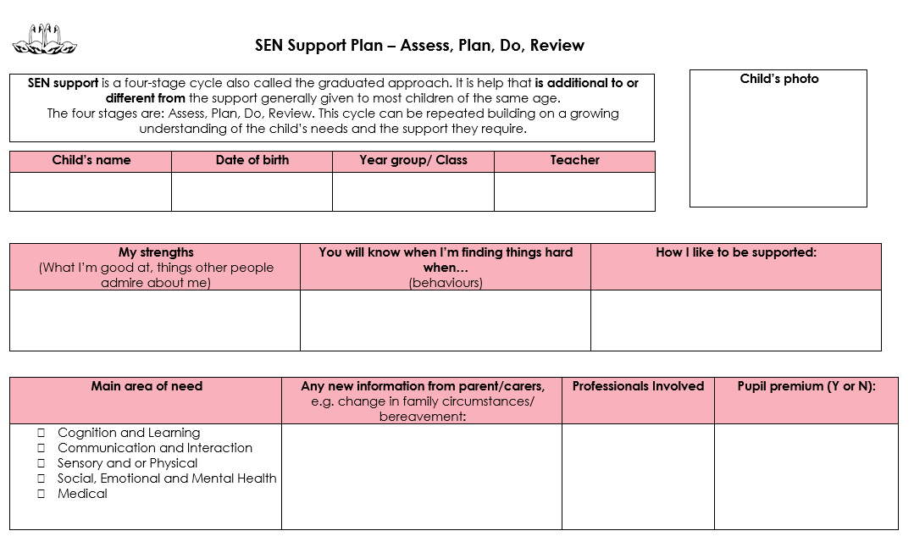


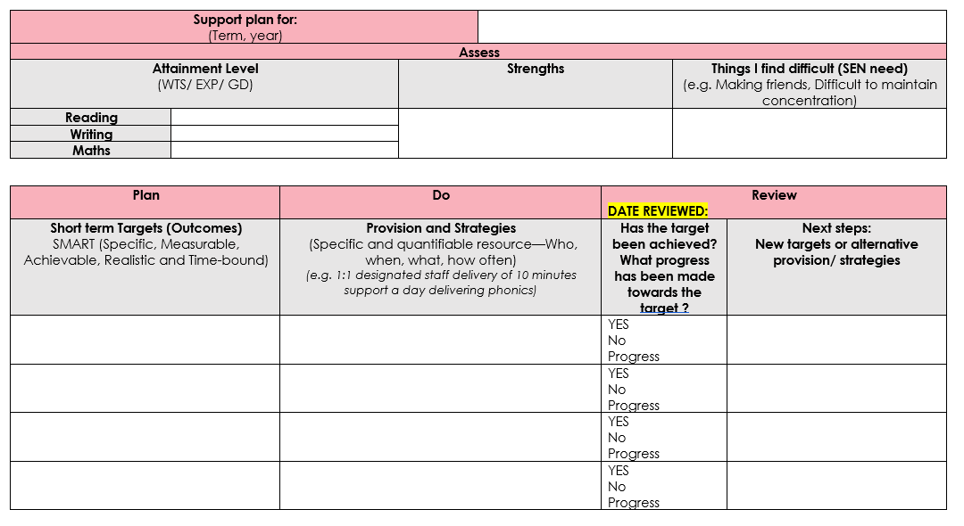

The nature of support offered will depend on the needs of each individual child. Sometimes it may also be necessary to involve a specialist from an outside agency. Parents and carers will be fully informed and involved at each stage of the process.
Person-centred approaches enable parents, children and teacher to co-produce SEN Support Plans. These will include targets that the children are working towards and strategies to support reaching these targets. The Support Plans will be reviewed on a termly basis.


✓ Regular attendance at parent consultation meetings, termly SEN Support Plan parent consultation meetings. Additional meetings with the SENDCO can be arranged by appointment throughout the school year.
✓ If your child is on the SEN Support Register, you will receive a copy of their SEN Support Plan which outlines their targets and the provision put in place to support them. While these will be reviewed regularly by teaching staff, a new plan with updated targets will be shared with you on a termly basis. Teachers will also meet termly with parents of children on the SEN Register in line with Parents’ Evenings.
✓ You will receive a written annual report on your child’s attainment and progress at the end of the summer term.
✓ Teachers also try to provide informal feedback at the end of the school day if something noteworthy has occurred and on occasions, work may be sent home for your child to share with you.

How will I know how my child is doing?

✓ The class teachers are responsible for monitoring and tracking the attainment and progress of pupils within their class.
✓ All teachers adapt their planning and tasks to ensure all lessons are accessible to all children.
✓ Small group or targeted interventions are used where there is an identified need.
✓ The children are also invited to share their views and opinions both through class discussions and as part of the SEN Support Plan.
✓ Termly pupil progress meeting information will be used to assess and current provision.
✓ The SENDCO is a member of SLT and ensures that termly meetings take place to review interventions, assess the effectiveness of current provision and to make the necessary changes for the next term.
✓ The SENDCO is responsible for creating a whole school provision map to demonstrate how the range of needs are being met across the school.
✓ SENDCO meetings discuss additional strategies or support, aside from pupil progress meetings.
How will the learning and development provision be matched to my child’s needs?

Tiered response to provision:
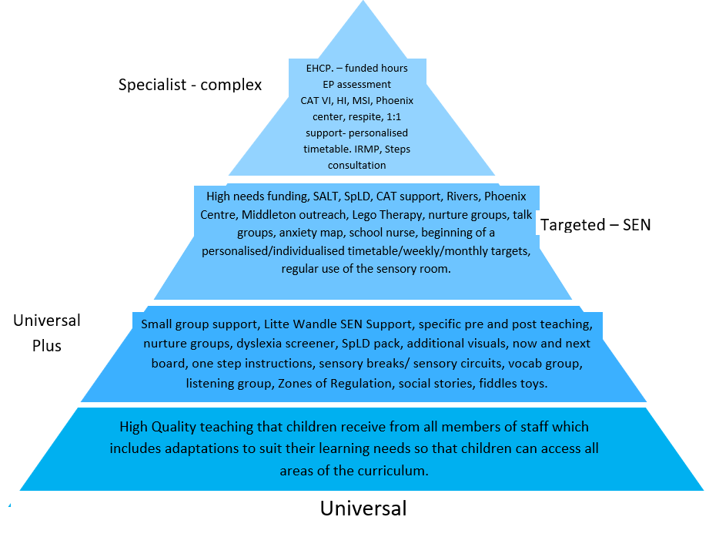
✓ Reinforcing the ethos of our School and BRIGHT values
✓ Teaching of PSHE - Personal, Social and Health Education.
✓ Participation in class circle time and whole school assemblies.
✓ Valuing pupil voice – through school council and pupil feedback questionnaires.
✓ Modelling positive relationships between staff, pupils and parents and carers.
✓ Whole school policy and approach to behaviour, including support from Rivers Outreach.
✓ Promoting the school rules.
✓ Regular Wellbeing Team Meetings carried out by our Wellbeing staff lead and our Wellbeing Council members
✓ Involvement in extracurricular activities.
✓ Access to a Family Support Worker by referral to CHEXS
✓ NHS services including School Nurse, Childrens Wellbeing Practitioners and Step 2 support
✓ Play leaders support inclusive play in the playground.
✓ Zones of Regulation programme for all classes to support emotional literacy
✓ Trauma Informed and Attachment Aware training – Therapeutic Approach
✓ Information regarding medical conditions will be handled sensitively, in line
with our policy, and the appropriate staff will be informed of specific needs.
✓ Mental Health Lead: Anna Sawyer (SENDCO)

What support will there be for my child’s overall wellbeing?

What training have the staff had, who support children with SEND?

✓ The SENDCO attends courses on updates to SEND and implementing the SEND Code of Practice and keeps the staff update with best practice and advice.
✓ SENDCO maintains regular attendance at cluster meetings (DSPL4).
✓ Staff training in staff meetings is provided to update staff on changes to the SEND Code of Practice and best practice and deliver relevant training based on the needs of children within the school.
✓ Staff training in staff meetings on provision mapping to plan provision for all pupils in each class.
✓ A skills audit for support staff has identified strengths within our support team and these needs can be used to match the needs of our pupils.
✓ Teachers and TAs attend relevant courses for continued professional development.
✓ The SENDCO is a qualified teacher and is in the process of achieving the National SENCO Award (NPQ SENCO).
✓ Dedicated SEN teaching assistants offer specialist level support.
✓ Regular support from external professionals, including: Speech and Language Therapy team, Speech Language Communication and Autism (SLCA) team, Physical and Neurological Impairment (PNI) team, Middleton School Outreach and the Behaviour Support Teams from the Phoenix Centre or Rivers Education Support Centre.

✓ SENDCO advice
✓ Speech Language Communication and Autism (SLCA) team, Physical and Neurological Impairment (PNI) team, Middleton School Outreach and the Behaviour Support Teams from the Phoenix Centre or Rivers Education Support Centre. A referral is required to access these services and this must be done through the SENDCO.
✓ Speech and Language Therapist (John Cane, ACCESS Speech and Language Therapy) working at Four Swannes once per week.
✓ Health services – School Nursing Service and NHS Speech and Language Therapy (some referrals can be made via your GP.)
✓ Services accessible through the local area, including therapy and counselling services, as well as family support workers.
✓ Behaviour support – either through Rivers ESC or the Phoenix service.
✓ Family support offered by CHEXS
What specialist services and expertise are available at or accessed by our school?

Support from external agencies is only available upon referral. Before referrals are made, there is a period of time where school-based assessments will need to take place. The views of the child and the parents or carers will also be sought to ensure everyone is fully informed and working towards the same goal.

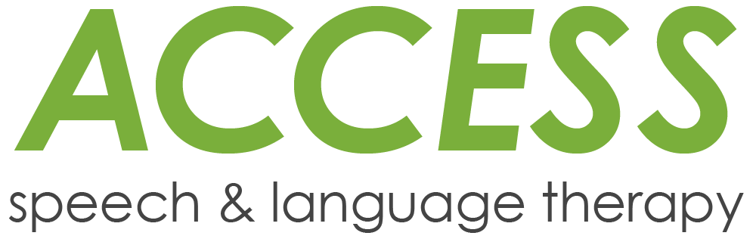



✓ Parent consultation meetings
✓ SEN Support Plan termly meetings
✓ Access to a Family Support Worker through CHEXS
✓ Parent Consultations
✓ Links from the school website to enhance learning
✓ Parent workshops – in school and advertised workshops organised by local services, such as CHEXS, SPACE for Neurodiversity, etc.
✓ Your Child’s Annual school report will also suggest ways to support your child in their learning
✓ Curriculum meetings and workshops to inform and provide tips or guidance.
✓ Activities may be sent home for you to practise with your child at home
How will you help me to support my child’s learning?





✓ You will be invited to attend parent consultation meetings three times during the school year. During the meetings, personalised targets will be discussed, as well as ideas on how to support your child further.
✓ We use person-centred approaches to consider how small changes can make a big difference.
✓ If your child is identified as having an additional need, the level of need and strategies to support your child will be fully discussed with you and your child.
✓ For some children with complex needs, where multiple agencies or services are involved, it may be necessary to refer to ‘Families First’ and put an ‘Early Help Module’ in place. Regular ‘Team Around the Family (TAF) meetings will take place to ensure appropriate support is actioned.
How does the school enable constructive partnership working with families?

For some children an Education Health and Care Plan (EHC Plan) may be required. The views of the child and the family are central to putting together a coordinated plan that involves advice from education, health and social care.
For more information about the EHC Needs Assessment process, please visit the local offer website: Hertfordshire Local Offer: EHCPs


How will my child be included in activities outside the classroom including school trips?

✓ The individual needs of some children will be shared with supervisory staff at playtimes and lunchtimes to ensure their health and wellbeing.
✓ Sports leaders are used during longer periods of play to engage with younger children and encourage social skills such as sharing and taking turns.
✓ Before a trip can take place, the appropriate risk assessments will be carried out to identify and problem solve any individual issues which might arise.
✓ Reasonable adjustments will be made, in all areas of school life, in order to meet the needs of all children.
✓ As much as possible, parents will be involved in the decision-making process.
✓ Please see your Year group’s Curriculum information page for more details.

How accessible is the school environment?
✓ Four Swannes is an accessible school, which complies with the Equality Act 2010. Please see the link below for more information:

Equality Act 2010

✓ Reasonable adjustments will be made where necessary, teachers record these on planning documents and on SEN Pupil Support Plans, as appropriate.

✓ The school Accessibility Plan is reviewed and updated according to need. This document can be accessed on the school website or via the school office upon request.

Who can I contact for further information?

✓ Class teacher
Via the school office on 01992 763939

✓ SENDCO: Mrs Anna Sawyer
Via the school office on the above telephone number or by email:
sendco@fourswannes.herts.sch.uk

✓ Head teacher: Mr. Alan Moore
Via the school office on the above telephone number or by email:
Mr A Moore: admin@fourswannes.herts.sch.uk

✓ SEND Governor: Jean Bailey
Via the school office on the above telephone number or by email:
admin@fourswannes.herts.sch.uk

✓ SENDIASS (Special Educational Needs or Disabilities Information, Advice and Support Services).
https://www.hertssendiass.org.uk/home.aspx
Tel: 01992 555847

✓ Hertfordshire Local Offer – all the information regarding local services available. https://www.hertfordshire.gov.uk/microsites/Local-Offer/The-Hertfordshire-LocalOffer.aspx

✓ KIDS – Offers information and support to parents and carers of disabled children and young people aged 0-25yrs in Hertfordshire.
KIDS
Tel: 01992 504013

We are a welcoming and open school. We always aim to resolve any problems that occur from time to time within school.
However, should it be required, a copy of the complaint’s procedure is available from the school office. It is also good to hear when things are working well, so please be sure to share positive comments with us too.

How will the school prepare and support my child to join the school, transfer to a new school or the next stage of education and life?
Nursery to Reception:

✓ Settling visit, opportunity to meet the teacher and visit the school;
✓ Session with parent/ carer prior to start – additional visits as necessary;
✓ Information evening;
✓ Home visit, where appropriate
✓ Transition booklet with photographs of the setting.
✓ Meetings with appropriate outside agencies.

Reception to Year 6:

✓ Information meeting/ letter home;
✓ Meet the new teacher and classroom sessions;
✓ Open evenings;
✓ Handover meetings;
✓ Transition booklet with photographs of the setting.
✓ Meetings with appropriate outside agencies

Secondary transfer or transfer to another setting:

✓ Open evenings;
✓ Taster days;
✓ Specialised secondary transfer transition sessions – appropriate to the needs of the child, to support and promote emotional wellbeing;
✓ Maps/ photographs to increase familiarity.

✓ All classrooms are equipped with interactive ‘Clever Touch’ technology.

✓ Each classroom is equipped with a variety of resources to support phonics, reading, writing and mathematical concepts.

✓ Speech and Language Therapist to assess and support individual children, as well as train and coach teaching staff in speech, language and communication interventions.

✓ Other topic-based equipment is centrally stored to allow access to all.

✓ Allocation of resources for each subject is based on budget allocations, which is decided by the Head teacher and the Governing Board.

✓ Funds and resources are allocated according to the level of need.

✓ Additional resources are sourced in response to specific needs of individual children

How are the school’s resources allocated and matched to children’s special educational needs?

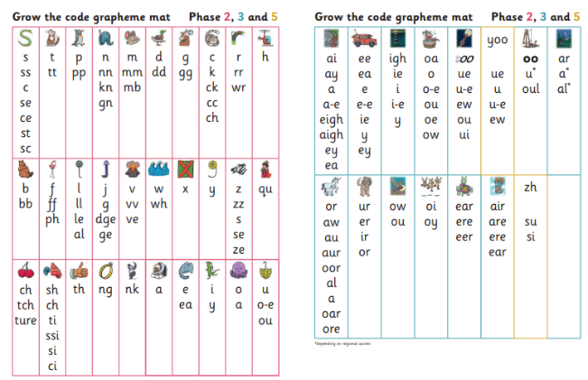

In exceptional circumstances additional funds can be applied for individual pupils, this is called Local High Needs Funding (LHNF).

✓ Pupil progress meetings will track the progress of all pupils and will identify groups or individuals that would benefit from intervention.
✓ Pupil Support Plan meetings will provide an opportunity for individual targets to be reviewed and updated for SEN pupils.
✓ Progress is measured against Age Related Expectations (ARE) as defined by HfL (Herts for Learning – Hertfordshire’s education advisory service.) Pupils are assessed to be working above ARE, broadly within ARE or below ARE. Sometimes pupils may need support with aspects of their learning but not have a special educational need. Targeted support may be put in place without children being on the SEN Register.
✓ More information about how SEN is defined can be found in our SEND policy on our school website.
✓ Early identification and intervention is our aim at Four Swannes. Supporting our children in the early years of their education to get the best start in their individual learning journey.
✓ Parents and carers will be involved if it is felt an intervention is needed or if outside agencies become involved in planning or delivering provision
How is the decision made about how much support my child will receive?

All additional support children receive will be recorded on class provision maps, as well as SEN Support Plans. The impact of this support on the children’s progress or development will be measured at regular intervals.

How are children and young people’s views listened to?


✓ Class discussions with trusted adults (class teachers and TAs)
✓ Children’s views and opinions about themselves and their learning are sought as part of their SEN Support Plan.
✓ Student Council, School Wellbeing Council and Diversity Council established with regular meetings
✓ Pupil voice is sought regarding different aspects of school (e.g. Safeguarding, Learning) by subject leaders as part of subject monitoring





How can I find information about the Local Authority’s Local Offer of services and provision for children and young people with special educational needs and disability?

✓ Information regarding the Hertfordshire Local Authority SEND Offer can be found at:

Schools and education | Hertfordshire County Council

Hertfordshire’s Local Offer is the door to finding information and support available for parents or carers of children and young people aged 0-25 with special educational needs or disabilities (SEND).

What other service, help and advice is there available to families of children with special educational needs and or disability?

This link will lead you directly to SEND pages within the Hertfordshire directory, which includes information on: activities and leisure, advice and support; childcare and education and training. If you need to speak to someone directly or require help to find the information you want, contact:

SENDIASS (Special Educational Needs or Disabilities Information, Advice and Support Services

Or

Kids

We are keen to know your thoughts about the Local Offer so we can continue to improve it. Please email localoffer@hertfordshire.gov.uk with your comments.

Further information

Helping families without internet access

If you know someone who would like to use the Local Offer but they cannot access the internet, ask them to contact their child’s school, their local library, or children's centre. Find your local library here or your local children's centre within the borough of Broxbourne here. If you reside in Essex you will need to access support through the local offer here. Applications for Education, health and Care needs assessments will also need to be made to the Essex SEND team

 | CHEXS are a family support charity based in Waltham Cross in the borough of Broxbourne.  The charity employs a team of highly trained family support workers to help both young people, parents and carers as well as the local community.
 | Information on what Autism is, and offers: support, advice, resources and courses.
 | Information on what Dyslexia is and offers information to support cooccurring difficulties at home and at school.
 | Information to support speech language and communication needs
 | Information to support dyspraxia.  NHS information on dyspraxia and developmental coordination disorder can also be accessed here.
 | Information and support where there may be concerns about  mental health.
 | Offer activities for children with SEND both term time and  during school holidays
 | Information to support children and their families with Autism,  ADHD or related condition. SPACE meet regularly to support  making connections and building relationships with others.
 | Offers support and advice directly to families living in the Hoddesdon or Broxbourne area. The service includes parenting courses, family support advice, Autism advice, as well as term time and school holiday activities for children.
Where else can I find reliable advice concerning SEND?

Glossary of Terms
ARE – Age Related Expectation  CAMHS – Childhood and Adolescent Mental Health Services  EHCP – Education and Health Care Plan  EHM – Early Help Module  LHNF – Local High Needs Funding  EP – Educational Psychologist  HABS – Hoddesdon and Broxbourne Settings  HfL – Herts for Learning  ICT – Information Communication Technology  LSA – Learning Support Assistant  TA – Teaching Assistant  OT – Occupational Therapist | PALMS – Positive behaviour, Autism, Learning disability and Mental health Services.  PT – Physiotherapist  SALT – Speech and language therapist  SENDCo – Special Educational Needs and Disabilities Coordinator  SEND- Special Educational Needs and/ or Disability.  SENDIASS – Special Educational Needs and Disability Information and Advice Support Service  SLT – Senior Leadership Team  TAF- Team Around the Family  PNI – Physical and Neurological Impairment

