
Four Swannes Primary School
Mathematics policy

Created: September 2026
Due for review: September 2027

Introduction
At Four Swannes Primary Schools we believe that all our pupils should achieve to their full potential: academically, creatively, socially, physically and personally. To achieve that end, we aim to create a caring, supportive, happy and secure learning environment where all the variety of successes of the children can be celebrated.
We live in a complex, high technology society where a wide range of mathematical concepts and skills is needed, both in work and non-work situations. Mathematics is both a key skill within school, and a life skill to be utilised throughout every person’s day to day experiences.
Maths is a core subject, in the National Curriculum. Mathematical understanding is also required in most other National Curriculum subjects for e.g. science, technology, geography.
Aim
We aim to develop lively, enquiring minds encouraging pupils to become self-motivated, confident and capable in order to solve problems that will become an integral part of their future.
The National Curriculum for mathematics aims to ensure that all pupils:
• Become fluent in the fundamentals of mathematics through varied and frequent practice with complexity increasing over time.
• Develop conceptual understanding and ability to recall and apply knowledge rapidly and accurately.
• Reason mathematically; follow a line of enquiry, conjecture relationships and generalisations.
• Develop an argument, justification and proof by using mathematic language.
• Problem solve by applying knowledge to a variety of routine and non-routine problems. Breaking down problems into simpler steps and persevering in answering.
The National Curriculum sets out year-by-year programmes of study for key stages 1 and 2. This ensures continuity and progression in the teaching of mathematics.

- Key Principles - Intent
  - At Four Swannes Primary School, we use a teaching for mastery approach.
  - Maths teaching for mastery supports the idea that everyone can do maths. All pupils are encouraged by the belief that by working hard at maths they can succeed.
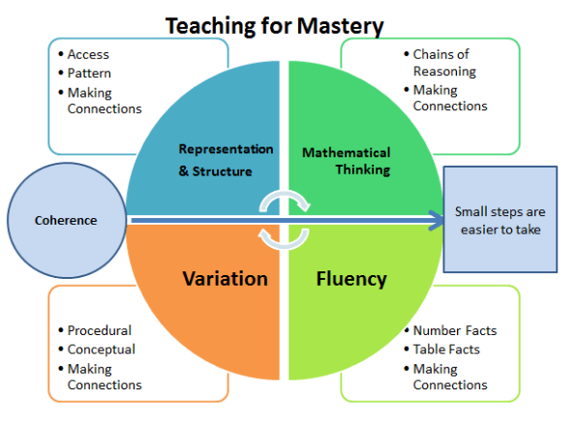
2. Principles of a Maths Mastery Approach
2.1 To establish:
Coherence Lessons are broken down into small, connected steps that gradually unfold the concept, providing access for all children and leading to a generalisation of the concept and the ability to apply the concept to a range of contexts. Representation and Structure Representations used in lessons expose the mathematical structure being taught, the aim being that students can do the maths without recourse to the representation. Mathematical Thinking If taught ideas are to be understood deeply, they must not merely be passively received but must be worked on by the student: thought about, reasoned with and discussed with others. Fluency Quick and efficient recall of facts and procedures and the flexibility to move between different contexts and representations of mathematics.

Variation
This is twofold. It is firstly about how the teacher represents the concept being taught, often in more than one way, to draw attention to critical aspects, and to develop deep and holistic understanding. It is also about the sequencing of the episodes, activities and exercises used within a lesson and follow up practice, paying attention to what is kept the same and what changes, to connect the mathematics and draw attention to mathematical concepts.
3. Implementation
3.1 Pupils in Key Stage 1 have a daily Maths lesson lasting between 50 minutes and 1 hour. Pupils in Key Stage 2 have a daily Maths lesson lasting approximately 1 hour.
3.2 Long-term planning
The National Curriculum for Mathematics 2014, Birth to 5 Matters 2021 and the Early Learning Goals (Number, Numerical Patterns) provide the long-term planning for mathematics taught in the school.
3.3 Medium term planning
Reception - Year 6 teachers use the White Rose schemes of learning, as well as the NCETM Mastering Number resources to create medium-term plan for each block. They support a mastery approach to teaching and learning and have number at their heart. They ensure teachers stay in the required key stage and support the ideal of depth before breadth. They support pupils working together as a whole group and provide plenty of time to build reasoning and problem-solving elements into the curriculum.
3.4 Short term planning
Lessons are planned to use a LO (Learning Objective) which sets out the key learning in the lesson. The LO (Learning Objective) is shared with the class during the lesson so that children can assess whether they have been successful.

3.5 Concrete/Pictorial/Abstract Approach Concrete representation
The children are first introduced to an idea or a skill by acting it out with real objects. In division, for example, this might be done by separating apples into groups of red ones and green ones or by sharing 12 biscuits amongst 6 children. This is a ‘hands on’ approach using real objects and it is the basis for conceptual understanding. Concrete apparatus such as numicon, double sided counters, base 10 apparatus and place value counters are used widely across School.
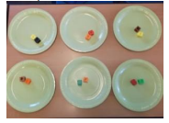
Pictorial representation
This is used when a child has sufficiently understood the hands-on experiences performed and can now relate them to representations, such as a diagram or picture of the problem. In the case of division this could be the action of circling objects.
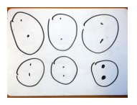
Abstract representation
The symbolic stage – a student is now capable of representing problems by using mathematical notation, for example: 12 ÷ 6 = 2. This is clearly the more confusing and mysterious of the three and without the ‘hands on’ and pictorial steps can be tricky for children to understand.
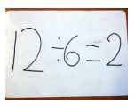

4 Additional teaching
4.1 In addition to a daily Maths lesson, there are other timetabled sessions within the school week where the children develop mental fluency. These fluency sessions are used to: • Recall and use appropriate number facts e.g. bonds & x tables •Recall and use learning they have been taught •Keep learning and vocabulary ‘fresh’ in their minds •Reactivate learning before the next layer is added (pre-teaching)
4.2 Maths Intervention is carefully planned for specific pupils within each year group and predominantly focuses on:
• Learning number bonds and counting • Recall of multiplication and division facts • Arithmetic procedures • Solving one and two step word problems Children practise these skills for a short time period (5 mins approx.) 3 or 4 times per week.
5 Maths in the Early Years
5.1 Teachers in the EYFS ensure the children learn through a mixture of adult led activities and child-initiated activities both inside and outside of the classroom. Mathematics is taught through an integrated approach. This is supported by the Birth to 5 Matters non statutory guidance as well as White Rose Medium term plans for EYFS Maths and the NCTM Mastering Number resources.
5.2 The EYFS Framework in relation to mathematics aims for our pupils to achieve the following Early Learning Goals:
ELG: Number • develop a deep understanding of number to 10, including the composition of each number. • Subitise up to 5. • Automatically recall number bonds up to 5 and some number bonds up to 10, including double facts.
ELG: Numerical Patterns • Verbally count beyond 20, recognising the pattern of the counting system. • Compare quantities up to 10 in different contexts, recognising when one quantity is greater than, less than or the same as the other quantity. • Explore and represent patterns within numbers up to 10, including evens and odds, double facts and how quantities can be distributed equally.
In addition, the curriculum includes rich opportunities for children to develop their spatial reasoning skills across all areas of mathematics including shape, space and measures.

6. Home Learning
6.1 Purple Mash is used to set exciting Maths games which are designed to help children master the mathematics concepts.
6.2 Practical mathematical activities are set as home learning tasks for EYFS pupils on Tapestry.
7. Marking and Feedback
7.1 Children mark their own work so that they are able to see immediately whether they have succeeded in their learning. This takes place at different points within the lesson and where the teacher deems it is appropriate. The teacher marks some pupil’s books in detail, giving them a focussed challenge or area to practise at the beginning of the next lesson.
7.2 Verbal feedback is provided to children continuously throughout the lesson. Staff may annotate pupils work to provide further scaffolds and modelling.
8. Assessment
8.1 Assessment is an integral part of teaching and learning and is a continuous process. Teachers make assessments of pupils daily through:
• regular marking of work • analysing errors and picking up on misconceptions • asking questions and listening to answers • facilitating and listening to discussions • making observations
These ongoing assessments inform future planning and teaching. Lessons are adapted readily and short-term planning is evaluated in light of these assessments.
8.2 Summative assessments are carried out across the school every term using National test style assessment materials. These scores, alongside judgements made from class work support the teacher to assess whether a child is meeting age related expectations.
8.3 In EYFS, children are measured at the end of Foundation stage against the Early Learning goals criteria for the mathematics specific area of development and are graded as ‘emerging’ or ‘expected’ for number and numerical patterns Early Learning Goals.
9 Special educational needs and disabilities (SEND)
Daily mathematics lessons are inclusive to pupils with special educational needs and disabilities. Where required, children’s IEPs incorporate suitable objectives from the National Curriculum for Mathematics or Development Matters and teachers keep these in mind when planning work. These targets may be worked upon with the lesson as well as on a 1:1 basis outside the mathematics lesson. Within the daily mathematics lesson, teachers have a responsibility to support children with SEND and also provide activities that ensures sufficient challenge for children who are high achievers. It is the teachers’ responsibility to ensure that all children are challenged at a level appropriate to their ability.
Pupils identified on the SEND register are assessed against National Curriculum Age related expectations in the year group in which they are in or from an earlier year group. Some children are assessed using the PIVATS document (pre–National Curriculum Levels).
10. Displays and resources in maths
Children of all ages and abilities should be encouraged to use resources to develop and explain their mathematical understanding. Some examples of resources used across the school include: Numicon, Base 10, Counters and Cuisenaire Rods. These resources support concrete representations and understanding of concepts throughout all key stages. Development of bar modelling supports children with visualising concepts and problems at all ages and stages. Children should be encouraged to develop their abstract, written representations of mathematical concepts and the calculation policy should be followed to ensure consistency throughout all key stages. Children in all stages should apply their knowledge and understanding of maths across the curriculum to solve problems. The maths display should clearly reflect the aspect of maths being taught at that time. The display should be interactive, creative and used as a working wall.
11. British Values
The maths curriculum promotes the British Values of tolerance and resilience through problem solving and understanding of complex concepts. Children are required to persevere to solve problems. Teamwork is central to maths through peer assessment, mentoring and group work. Mutual respect is developed as children work together and build confidence in one another. Children can feel safe to make mistakes and take risks in problem solving, thus developing self-confidence and esteem. Children are encouraged to become life-long learners alongside developing their mathematical skills across the curriculum through enterprising and problem solving.
12. Monitoring and Review
The subject is monitored in the Autumn Term by the leadership team. Monitoring involves lesson observations, planning and book scrutiny, learning walks, monitoring of pupil voice and data analysis. A report is produced and submitted to the governors and headteacher. Staff are provided with both general feedback and individual feedback regarding the scrutiny. In the Summer Term, the targets provided to each teacher in the scrutiny are monitored and reviewed. Data analysis takes place each term throughout the year.

